Arab-Israeli Conflict Vocabulary
Benjamin Netanyahu:
Prime Minister of Israel. Leader of the Likud Party.

Mahmoud Abbas:
President palestinian national authority
chairman PLO, leader fatah

Ismail Haniyeh:
(Disputed) Prime Minister Palestinian National Authority. Ruling over Gaza Strip.

Arab League:
Regional org of arab states
Seeks to unify arab policy on issues, particularly israel

Declaration of principles:
(1993) est. interim self-government in gaza strip and west bank. transitional period was not to exceed five years.

Road Map:
(2003) Peace Plan drafted by the quartet – the US, EU, UN, and Russia.
Called for immediate cease-fire, a crackdown on palestinian militias, an israeli withdrawal from palestinian towns, and the dismantling of jewish settlements erected since 2001.

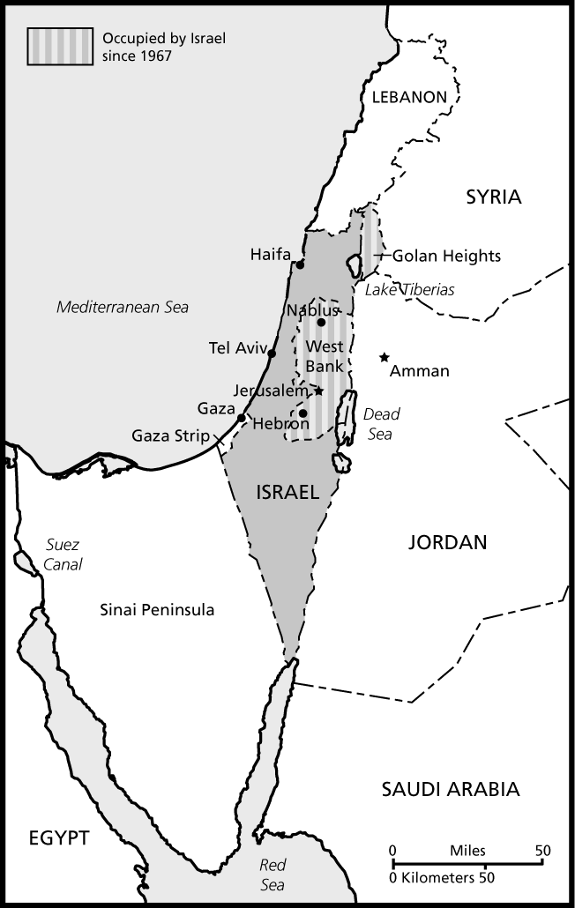
Golan Heights: Sinai Peninsula:
Occupied during the Six Day War (1967) Peninsula between Egypt Proper & Israel taken by israel
Provides fresh water and protection. during six Day War (1967). Returned to Egypt as part of the
Camp David Accords (1978).

West Bank: Gaza Strip:
Largest Occupied Territory. palestinian population once occupied by Israel
Large number of israeli settlements Controlled by Hamas since 2007, frequent
Large number of israeli settlements Attacks on Israel have led to violence & economic blockade
Israelis:  Citizens of Israel  Primarily a result of immigration from Europe.  palestinians:  Arabs living in the area formerly known as palestine  Knesset:  Israeli Parliament  Housed in Jerusalem  Tzipi Livni  Current israeli opposition leader  Leader of kadima, largest party in knesset  IDF:  israeli defense forces - Israel’s military  led by Ehud Barak  PLO:  Palestinian liberation organization  formed 1964 with goal of creating a palestinian state  PNA:  Palestinian National authority (sometimes PA) 1994 Oslo - interim self-government, governs W.Bank  Hamas:  “courage and bravery” sr leader Khaled Meshaal  islamic fundamentalist group - claims responsibility for most terrorist activities against Israel, including suicide bombings. In control of Gaza since 2007 – refuses to recognize israel’s right to exist  Fatah:  Palestinian political party, Largest Faction of PLO  Maintains number of militant groups  Intifada:  uprising of palestinian youth in occupied territories  “Shaking off” israeli rule | Occupied Territories:  disputed areas of land controlled by israel as a result of war  israeli settlers/settlements:  israeli citizens who live and have businesses in small communities in the occupied territories, especially the west bank.  palestinian refugees:  750,000 palestinians who left/fled their homes during the first arab-israeli war  right of return:  supported by resolution 194  descendants of palestinians who fled israel in 1948 can claim a legal and moral right to return to their former homes in israel.  zionism:  desire of jews in the diaspora for a homeland led to  migration of jews to the area called palestine  resolution 181:  (1947) established the partition of the area palestine into separate jewish and arab states  Resolution 242:  (1967) Declared TERRITORIAL ACQUISITIONS by war inadmissible. Called for the withdrawal of israeli armed forces from occupied territories.  Resolution 338:  (1973) Called for the implementation of resolution 242. Cease-fire to 1973 War, called for negotiations to start.  Security fence/The Wall:  border along west bank settlements to protect settlers from attacks, primarily suicide bombings. Additional fence along gaza strip border.

